**KiberaTB Justifications**

* **Students**
  + Students go to school every month except for July and August
  + Students go to school only from Monday to Friday
  + Are in school from 7:30 to 3:30 (8 to 4 or 0800 to 1600)
  + Source: A variety of different schools.
* **Employed People**
  + Maximum work time in Kenya is 52 hours. Staying period at work is thus between 5-9 hours (<http://www.mywage.org/kenya/home/labour-laws/work-and-wages/overtime-paid-public-holidays>).
* **Businesses Distribution**
  + The probability of visiting a business is based on a standard bell curve. Each business is assigned a popularity value of a double between [0,1) . When selecting which business to go to, a new random value is generated and a business in that respective distribution is selected.
* **Employee Capacity**
  + Schools:
    - Kibera school for girls has 26 employees (<http://shininghopeforcommunities.org/projects/ksg/meet-the-staff/>) Kibera primary school has 28 employees (<http://www.huduma.info/conspiracy-against-pupils/>). PCEA Silanga employees 8 (<http://www.kibera.bourock.org.uk/pcea2.html>). This means average employment at a school is 21 people.
  + Informal Sectors
    - For an informal business, the average number of employees is between 5 and 10 (UN (Challenge of slums) )
* **Activity Scheduling**
  + Visiting Restaurants/Bars:
    - Assumption here is that the average adult will visit a restaurant or bar between 1 and 3 times a week. Staying period is assumed at 1 hour.
* **Households**
  + Households start off with the minimum water requirement for the family (minWaterRequirementPerMember * Number of Members)
* **TB Assumptions**
  + Chance of someone with HIV and TB latent infection developing into TB disease is 7-10% per year (<http://www.colorado.gov/cs/Satellite?blobcol=urldata&blobheadername1=Content-Disposition&blobheadername2=Content-Type&blobheadervalue1=inline%3B+filename%3D%22TB+and+HIV.pdf%22&blobheadervalue2=application%2Fpdf&blobkey=id&blobtable=MungoBlobs&blobwhere=1251811775014&ssbinary=true>)
  + Percent chance that someone WITHOUT HIV and latent TB infection will develop TB in their lifetime is 5-10%
    - <http://www.cdc.gov/tb/publications/factsheets/general/ltbiandactivetb.htm>
  + The time that it takes from initial infection to when the person shows positive on a TB test is 2-12 weeks or 336-2016 hours
    - <http://www.vanderbilt.edu/HRS/wellness/OHC/ohctb.pdf>
  + Someone with untreated TB Disease will die within 3 years of onset of disease
    - Source: <http://www.plosone.org/article/info%3Adoi%2F10.1371%2Fjournal.pone.0017601>
  + Someone with untreated TB Disease and untreated HIV will die in less than 6 months of onset of disease
    - Source: <http://www.plosone.org/article/info%3Adoi%2F10.1371%2Fjournal.pone.0017601>
  + Someone with TB Disease and started treatment is still contagious for 2-4 weeks
    - Source: <http://hss.sbcounty.gov/psd/Forms/Health_Forms/Tuberculosis.htm>
  + TB Testing time takes 38-72 hours
    - Source: <http://www.cdc.gov/tb/topic/testing/default.htm>
* **HIV Assumptions**
  + Someone is considered to have HIV (from when treatment is recommended) when their CD4 count is <= 350
    - Source: <http://hab.hrsa.gov/deliverhivaidscare/clinicalguide11/cg-206_cd4_monitoring.html>
    - <http://www.scielo.br/scielo.php?script=sci_arttext&pid=S1413-86702003000200010>
  + For someone with untreated HIV, their CD4 count drops between 50-80 cells/mm^3 per year
    - Source: <http://hab.hrsa.gov/deliverhivaidscare/clinicalguide11/cg-206_cd4_monitoring.html>
  + When someone has HIV, their TB infection will become TB disease if their CD4 count is between 36-68 cells/mm^3 lower (so if their CD4 count is between 282-314, they will develop TB disease)
    - Source: <http://malthus.micro.med.umich.edu/lab/pubs/mmnp2008714.pdf>
    - <http://www.scielo.br/scielo.php?script=sci_arttext&pid=S1413-86702003000200010>
  + Survival time for someone with untreated HIV is at MAX 12 years
    - Source: <http://www.hiv.va.gov/patient/faqs/life-expectancy-with-HIV.asp>
* TB Spreading Assumptions
  + Kibera has a 14% adult HIV prevalence rate
    - Source: <http://d-scholarship.pitt.edu/10936/1/PattersonHThesis2011_(2).pdf>

**Verifications of the Model**

* If everyone has HIV and TB Infection, then all of them will die within 11,000 timesteps (assuming that it takes at max 5000 timesteps to from TB infection to disease and then max 6 months from onset of disease to death)

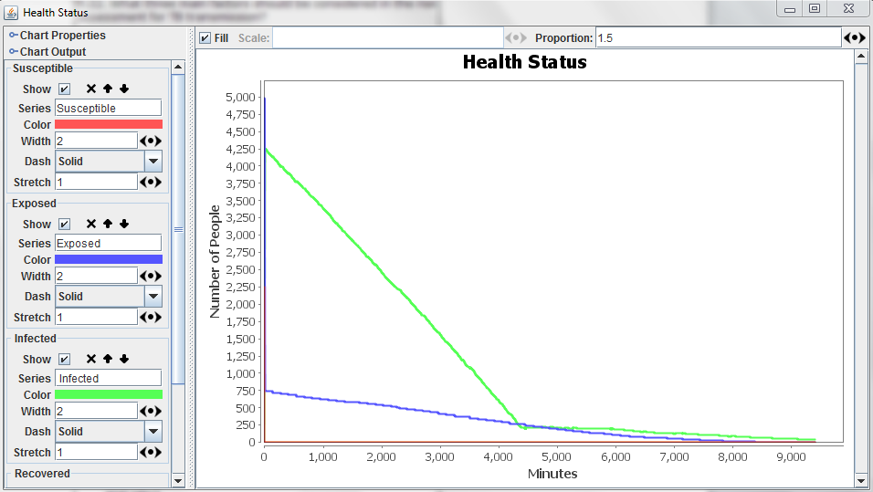

* 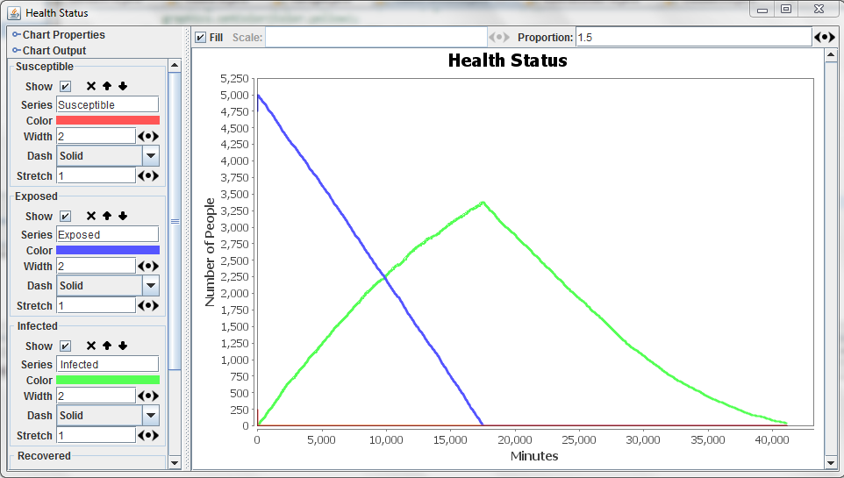If everyone doesn’t have HIV and everyone has TB infection, then given that all TB infection turns into untreated TB disease, the entire population will die in a max of 5 years (2 years max for infection to disease and 3 years from disease to death)

**TB Spreading**

* The Infectious Dose (ID) of TB is 1-10 bacilli
  + Source: <http://www.biosafety.be/CU/PDF/Mtub_Final_DL.pdf>
* A TB bacillus has a reproduction rate between 15-20 hours
  + Source: <http://textbookofbacteriology.net/tuberculosis.html>
* Concentration of TB in saliva is 650000 bacilli/mL
  + Source: <http://www.camra.msu.edu/documents/CAMRA_TB_ALERT.pdf> and Yeager et. al (1967)
* Concentration of saliva per cough is 6 * 10^-8 mL/cough
  + Source: <http://www.camra.msu.edu/documents/CAMRA_TB_ALERT.pdf>
* Average number of coughs is between 10-15
  + <http://www.camra.msu.edu/documents/CAMRA_TB_ALERT.pdf>